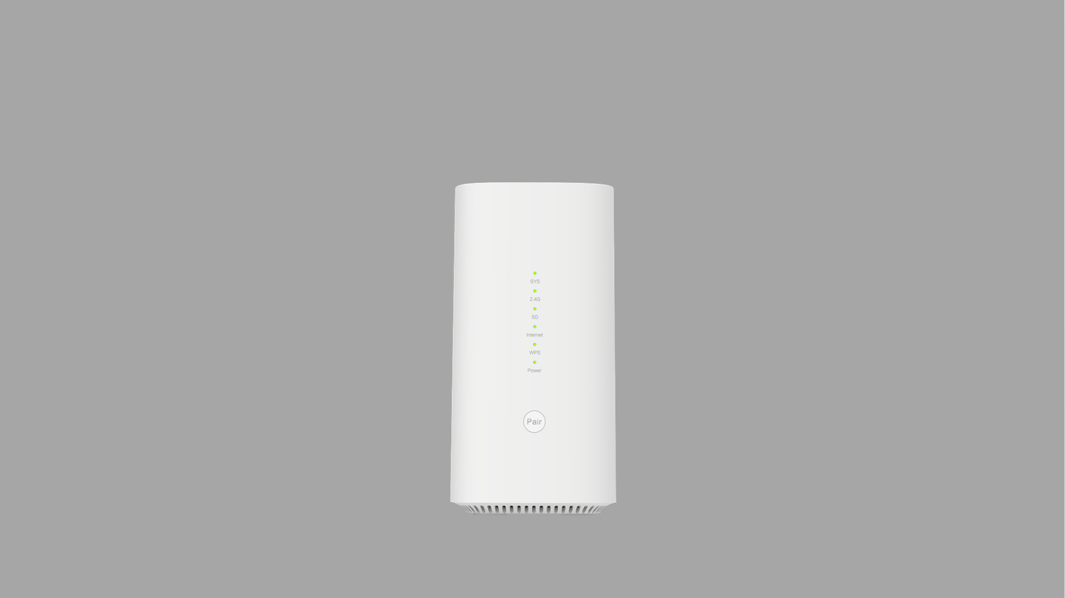



**BE6500**

be



**QoS**



**VPN**

**TR069**

**BRAX FA1706**

BE6500 Wi-Fi 7 Router

## Solution

* CPU: Qualcomm IPQ5322
* WiFi: Qualcomm QCN6224
* PHY: Qualcomm QCA8081
* Switch: Qualcomm QCA8384

## Key Features

**Key Benefits**

* Wi-Fi 7
* VPN
* Multiple management

**High Rate WiFi 7**

* BE6500
* MU-MIMO
* Multi-Link Operation
* MESH

**High Performance Antennas**

* Internal WiFi antennas
* Multi-frequency coverage
* High gain

**Security assurance**

* Stable firewall
* Multiple filtering rules
* Multiple security protocols
* Support backup of configuration files
* Online update and maintenance

## Overview

BRAX FA1706 is a WiFi7 router that supports the newest IEEE 802.11 be standards. It implements the conversion between wired Ethernet data and wireless WiFi data. The MU-MIMO, beamforming and MLO function can ensure the high data rate and signal quality when several users are using simultaneously.

Besides the high-performance WLAN function, it also supplies firewall, QoS, maintenance, and management functions. It provides the stable services to home and enterprise users.

## High Performance

BRAX FA1706 WiFi7 router supports the newest IEEE 802.11 be standards. The BE6500 data rate can easily supply the HD video, online game, and high-quality network applications. The MU-MIMO, beamforming and MLO function can ensure the high data rate and signal quality when several users are using simultaneously.

## Versatility

Besides the basic WLAN functions, BRAX FA1706 WiFi7 router also support firewall, VPN, QoS and etc. It satisfies the multi-directional requirements of users. Multiple management and maintenance methods (TR069/CLI/APP*) are convenient for checking and operating. The software online update tool will also constantly provide the upgrade of these functions.

## Customizable Software

The operating system and web-based GUI for BRAX FA1706 WiFi7 router are secondary development of OpenWRT, which have high plasticity and rich customization functions. Depends on different requirements of customer, the software is very customizable beyond basic functionality.

v 1.0.0

**BRAX FA1706**

BE6500 Wi-Fi 7 Router

|  |  |  |
| --- | --- | --- |
| Features & Specification | | |
| **BE6500 Data rate**   * 2.4GHz 40MHz 2ss: 688Mbps * 5GHz 160MHz 4ss: 5765Mbps   **Wireless LAN**   * Support 802.11 a/b/g/n/ac/ax/be standards * 2.4GHz/5GHz frequency range * 20/40/80/160 MHz bandwidth * Channel adaption * MSSID + Guest network * WPS: PBC/PIN modes * WPA/WPA2/WPA3 security * AP Isolation/SSID Isolation * SSID and WAN binding * Beamforming * Multi-Link Operation   **MESH**   * WiFi son/EasyMESH * One-button Matching   **Wi-Fi Antennas**   * Internal 2*2 2.4GHz antennas * Internal 4*4 5GHz antennas * Gain: 5dBi * VSWR: <2   **Operation Modes**   * Bridge * Route | **Firewall**   * Built-in NAT firewall * Defense of DoS、ARP attacks/Port scanning * DHCP/ARP/IGMP message suppression * MAC/URL filtering * Inflow/outflow filtering of IP/Protocol/Port   **Quality of Service Control**   * 802.11e WMM * Classification of service flow * DSCP/802.1 p * SP and WRR mode * Port/VLAN/ IP rate limitation   **Network Protocols and Features**   * Connection modes: PPPoE/DHCP/Static * IPv4, IPv6, IPv4/IPv6 * DHCP v4/v6 server * Static (v4/v6) routing and RIP-1/2, RIPng * NAT/ALG/DMZ/virtual server * ARP/ICMP/DNS proxy * Dynamic Domain Name System (DDNS) * IGMP snooping and IGMP proxy * MLD snooping and MLD proxy * NTP * VLAN * VPN: PPTP/L2TP/IPSec | **Management**   * WebUI local management * TR069/SNMP remote management * Online and local software update/rollback * Configuration data upload and download * Local and remote diagnostic   **Hardware Specification**  **Physical Interface**   * WAN port-RJ45 1* 2.5GE * LAN ports-RJ45 1* 2.5GE + 2 * GE * Power port   **Button**   * WPS * Reset   **LED indicators**   * WAN indicator * WLAN indicator * LAN indicator * Power indicator * WPS indicator   **Physical specification**   * Dimensions: TBD * Operating temperature: -10°C to 45°C * Storage temperature: -40°C to 70°C * Humidity: 5% – 95% (non-condensing) |

